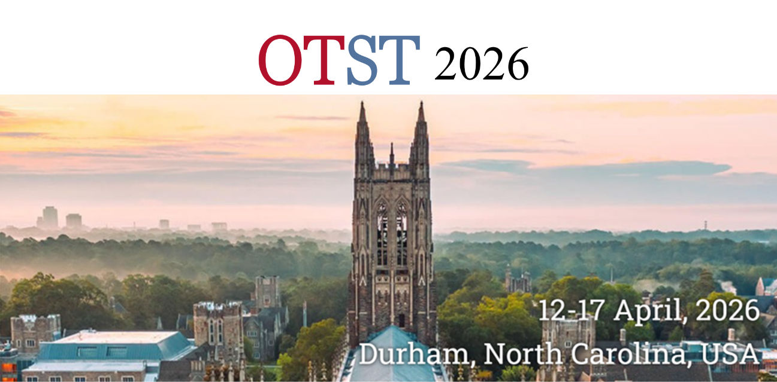

Optical Terahertz Science and Technology
Conference Program

Platinum Sponsors

Gold Sponsors



Silver Sponsors



Bronze Sponsors
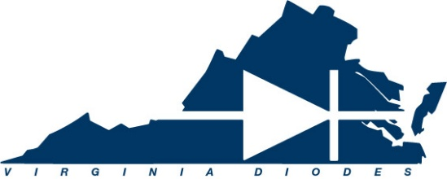

Sunday, April 12, 2026

09:30 AM | Registration
 | Student Tutorials (held in Schiciano A/B)
11:00 AM | Tutorial 1: THz Liquid Photonics  X.-C. Zhang, University of Rochester, USA
12:00 PM | Tutorial 2: Interpreting anisotropic terahertz microspectroscopy data of protein intramolecular vibrational changes with ligand binding  Andrea Markelz, University at Buffalo, USA
1:00 PM –  2:00 PM | Lunch
2:00 PM | Tutorial 3: Optical Pump THz Probe Spectroscopy  Jens Neu, University of North Texas, USA
3:00 PM | Tutorial 4: Applications of Metamaterials  Younes Ra’di, Syracuse University, USA

07:30 AM | Registration
08:20 AM –  08:30 AM | Opening Remarks  Willie Padilla, Duke University & Hassan Arbab, Stony Brook University
Session: Artificial Intelligence and Machine Learning
Chair: Willie Padilla, Duke University, USA
08:30 AM | [Keynote] Programming Diffraction for Terahertz Information Processing  Aydogan Ozcan, University of California, Los Angles, USA | Mo-A1-1
09:15 AM | [Invited] Machine-Learning Assisted Design of Reconfigurable Intelligent Surfaces  Marco Rahm, University of Kaiserslautern, Germany | Mo-A1-2
09:45 AM | High-Q Guided-Mode Resonances of Metagratings for Enhanced Terahertz Sensing  Joshua Mornhinweg, Harvard University, USA | Mo-A1-3
10:00 AM –  10:45 AM | Coffee Break
Session: Quantum and Nonlinear Optics I
Chair: Hassan Arbab, Stony Brook University, USA
10:45 AM | [Keynote] Nonlinear Dynamics in Terahertz Dirac Metamaterials  Richard Averitt, University of California, San Diego, USA | Mo-A2-1
11:30 AM | Effective-Hamiltonian reconstruction through Bloch-wave interferometry in bulk GaAs driven by strong THz fields  Seamus O’Hara, University of Pennsylvania, USA | Mo-A2-2
11:45 AM | Time-resolved spectroscopy of ultrafast carrier dynamics at the atomic limit  Kaedon Cleland-Host, Michigan State University, USA | Mo-A2-3
12:00 PM – 01:30 PM | Lunch (Provided)
Session: Novel Terahertz Photonics Devices and Applications I
Chair: Aydogan Ozcan, University of California, Los Angeles, USA
01:30 PM | [Keynote] Exploration of THz Photonics under Extreme Conditions  X.-C. Zhang, University of Rochester, USA | Mo-B1-1
02:15 PM | [Invited] Structured THz light with diffractive optical networks  Berardi Sensale-Rodriguez, University of Utah, USA | Mo-B1-2
02:45 PM | Scaled Structured Radar Using a THz Time-Domain Spectrometer  Hichem Guerboukha, University of Missouri-Kansas City, USA | Mo-B1-3
03:00 PM | Spacetime near-field imaging and control of THz surface plasmon polaritons in graphene  Simon Anglhuber, University of Regensburg, Germany | Mo-B1-4
03:15 PM – 04:00 PM | Coffee Break
Session: Terahertz Spectroscopy
Chair: Richard Averitt, University of California, San Diego, USA
04:00 PM | [Invited] When Vibrations Become Chemistry: Terahertz Phonons Dictate Reactivity in Organic Materials  Michael Ruggiero, University of Rochester, USA | Mo-B2-1
04:30 PM | Competing CDW orders in DyTe3 studied by THz-STM  Sheng Lee, Michigan State University, USA | Mo-B2-2
04:45 PM | Be Flexible: Strain-Induced Changes in Optoelectronic Properties of InGaAs  Terng Junn Keat, University of Oxford, UK | Mo-B2-3
05:00 PM | Lightwave Engineering of Excitonic States in an Atomically Thin Semiconductor  Omer Kneller, University of Regensburg, Germany | Mo-B2-4
Dinner on your own.

07:30 AM | Registration
Session: Terahertz Near-field Optics and Phenomena I
Chair: Daniel Mittleman, Brown University, USA
08:00 AM | [Keynote] Recent Advances in THz near-field Nanoscopy  Mengkun Liu, Stony Brook University, USA | Tu-A1-1
08:45 AM | [Invited] Atomic-scale terahertz time-domain spectroscopy  Tyler Cocker, Michigan State University, USA | Tu-A1-2
09:15 AM | [Invited] Subcycle terahertz microscopy: how to reach the smallest spatial scales  Tom Siday, University of Birmingham, UK | Tu-A1-3
09:45 AM | Advancing lightwave-driven scanning tunneling microscopy to attosecond resolution  Katharina Glöckl, University of Regensburg, USA | Tu-A1-4
10:00 AM –  10:45 AM | Coffee Break
Session: Terahertz Bio-Photonics I
Chair: Masayoshi Tonouchi, Okayama University, Japan
10:45 AM | [Keynote] Utilizing a perturbed Fabry-Perot effect to enhance THz spectroscopy of surface tissue  Zachary Taylor, Aalto University, Finland | Tu-A2-1
11:30 AM | Single-cell Terahertz Imaging Using Scanning Point THz Source Microscopy  Kazunori Serita, Waseda University, USA | Tu-A2-2
11:45 PM | Double Debye dielectric function in THz Biophotonics: preventing overfitting under limited bandwidth and dimensionality reduction for AI/ML models  Erica Heller, Stony Brook University, USA | Tu-A2-3
12:00 PM – 01:30 PM | Lunch (Provided)
Session: Novel Terahertz Photonics Devices and Applications II
Chair: Zachary Taylor, Aalto University, Finland
01:30 PM | [Keynote] Diagnosis and treatment of cancer using terahertz radiation  Joo-Hiuk Son, University of Seoul, South Korea | Tu-B1-1
02:15 PM | [Invited] Advanced photoconductive THz devices for time-domain spectroscopy, imaging and ellipsometry  James Lloyd-Hughes, University of Warwick, UK | Tu-B1-2
02:45 PM | Chiral Multimode Terahertz Deep-Strong Coupling  Lucy Hale, ETH, Zurich, USA | Tu-B1-3
03:00 PM | Broadband Terahertz Quarter-Wave Plates  Hou-Tong Chen, Los Alamos National Laboratory, USA | Tu-B1-4
03:15 PM – 04:00 PM | Coffee Break
Session: Non-Destructive Testing I
Chair: Hou-Tong Chen, Los Alamos National Laboratory, USA
04:00 PM | [Invited] Enhanced terahertz nondestructive evaluation of materials  David Citrin, Georgia Institute of Technology, USA | Tu-B2-1
04:30 PM | Multi-Scale Attention Residual Network-Driven Terahertz Imaging for Damage Visualization in GFRP Composite  Min Zhai, Shenzen University, China | Tu-B2-2
04:45 PM | Weakly Supervised Damage Localization in GFRP Laminates Using Terahertz Imaging and Deep Learning  Niyem Mawenbe Bawana, Georgia Institute of Technology, USA | Tu-B2-3
05:00 PM | Terahertz nondestructive mapping of ABF thickness on embedded die in glass substrate  Erwan Emile, Georgia Tech-CNRS, France | Tu-B2-4
05:15 PM – 07:00 PM | Poster Session
 | Terahertz Imaging of Cellulose Nano Fiber Composites  Atsushi Nakanishi, Hamamatsu Photonics K.K., Japan | P1
 | Accurate in situ calibration of THz polarimetry imaging systems using leaky wire grid polarizers  Arash Karimi, Stony Brook University, USA | P2
 | Single-shot coherent detection of ultrabroadband millijoule-class THz pulses  Alexander Ohrt, Technical University of Denmark, Denmark  Terahertz Spectroscopy Data Augmentation and EfficientVMamba Model for Drug Classification  Nan Zhang, National University of Singapore, Singapore  Lightwave-driven flat bands in a van der Waals crystal  Changhua Bao, University of Regensburg, Germany  3D UV-Lithography-Fabricated Metamaterial Band-Stop Filters for the 1.8-2.7 THz Band  Danil Khaiumov, University of North Texas, Denton, USA  An Ultra-thin and Compact Terahertz Metamaterial Sensor Excited by a Point Terahertz Source  Kazunori Serita, Waseda University, USA  THz QC-VECSEL with folded cavity for reduced free-spectral-range  Michela Mattia, University of California, Los Angeles, USA  An Enhanced Physics-Aware Generative Adversarial Network for Terahertz Image Super-Resolution Restoration  Min Zhai, Shenzhen University, China  Dielectric Characterization of BNNT-Reinforced PMMA Using Terahertz Time-Domain Spectroscopy  Min Zhai, Shenzhen University, China  Toward high repetition rate terahertz generation using a LiNbO3 Cherenkov-type optical-to-terahertz converter  Alexandre Fahy, CORIA, France  Terahertz Spectroscopic study of a (110)- oriented SrRuO₃ thin film grown in (110)- DyScO₃ substrate  Amartya Sengupta, Indian Institute of Technology, Delhi, India  Gires-Tournois Interferometer-Based Output Coupler Mirrors for Dispersion Compensation in Terahertz Quantum-Cascade VECSELs  Jordane Bloomfield, University of California, Los Angeles, USA  Optical Feature-Based Identification of Kidney Stones in the THz Regime  Soumyajyoti Mallick, Universite de Lorraine, France  Terahertz Pulsed Imaging with a Narrow Bandpass Filter  Zeno Chen, Brown University, USA | P3  P4  P5  P6  P7  P8  P9  P10  P11  P12  P13  P14  P15

Dinner on your own.

07:30 AM | Registration
Session: THz QCLs and Sensing
Chair: Michael Johnston, University of Oxford, UK
08:00 AM | [Keynote] Nonlinear optics and combs in terahertz quantum cascade lasers  David Burghoff, California Institute of Technology, USA | We-A1-1
08:45 AM | [Invited] Development of Terahertz Sensing Components and Applications  Chiko Otani, RIKEN, Japan | We-A1-2
09:15 AM | [Invited] QCL-pumped molecular THz lasers  Henry Everitt, US Army DEVCOM, USA | We-A1-3
09:45 AM | Flip-chip bonding of THz QC-laser to silicon substrate for improved CW operating temperature  Daniel McGovern, University of California, Los Angeles, USA | We-A1-4
10:00 AM –  10:45 AM | Coffee Break
Session: Terahertz Communications
Chair: Willie Padilla, Duke University, USA
10:45 AM | [Keynote] Terahertz Sensing and Communications in the Near Field  Daniel Mittleman, Brown University, USA | We-A2-1
11:30 AM | Widely tunable terahertz molecular laser for wireless communications  Paul Chevalier, Harvard University, USA | We-A2-2
11:45 AM | Self-Healing Fidelity of Airy Beams Generated from Distributed Apertures  Kevin Mutai, Brown University, USA | We-A2-3
12:00 PM – 01:30 PM | Lunch (Provided)
Session: Novel Terahertz Photonics Devices and Applications III
Chair: Mengkun Liu, Stony Brook University, USA
01:30 PM | [Keynote] New directions in high average power, ultrafast laser-driven THz sources  Clara Saraceno, Ruhr University Bochum, Germany | We-B1-1
02:15 PM | [Invited] Spectroscopic Terahertz Imaging using Parametric Generation and Detection  Kosuke Murate, Nagoya University, Japan | We-B1-2
02:45 PM | Terahertz field control of surface topology probed with subatomic resolution  Stephanie Adams, Michigan State University, USA | We-B1-3
03:00 PM | Lightwave-driven ballistic spintronics  Philipp Weißenberger, University of Regensburg, Germany | We-B1-4
03:15 PM – 04:00 PM | Coffee Break
Session: Quantum and Nonlinear Optics II
Chair: Clara Saraceno, Ruhr University Bochum, Germany
04:00 PM | Continuous-Wave Multi-THz Microscopy for All-Optical Imaging at the Atomic Scale  Svenja Nerreter, University of Regensburg, Germany | We-B2-1
04:15 PM | THz-Driven Symmetry Modulation in MnPS3  Martin Cross, SLAC National Accelerator Lab, USA | We-B2-2
04:30 PM | Terahertz-Field-Induced Charging and Extreme Tunnel Currents through Single-Atom Defects  Austin Hayes, Michigan State University, USA | We-B2-3
07:00 PM – 09:30 PM | Conference Banquet  Location: Presidents I, Washington Duke Inn & Golf Club

07:30 AM | Registration
Session: Non-Destructive Testing II
Chair: David Citrin, Georgia Institute of Technology, USA
08:00 AM | [Keynote] Towards quantum-cascade VECSELs as THz spectroscopic sources  Benjamin Williams, University of California, Los Angeles, USA | Th-A1-1
08:45 AM | [Invited] Terahertz Time-Domain Spectroscopy for Plastic Classification in Waste Sorting and Recycling  Pernille Klarskov Hansen, Aarhus University, Denmark | Th-A1-2
09:15 AM | [Invited] Optical and THz sensing provide objective and sensitive assessment of degradation in marble heritage structure  Aparajita Bandyopadhyay, Indian Institute of Technology, Delhi, India | Th-A1-3
09:45 AM | Detecting Presence of Hemp Oil Chemical Treatment in Standard Copier Paper Through Terahertz Time-Domain Spectroscopy  Charles Chimera, University of Rochester, USA | Th-A1-4
10:00 AM –  10:45 AM | Coffee Break
Session: Terahertz Bio-Photonics II
Chair: Hassan Arbab, Stony Brook University, USA
10:45 AM | [Keynote] Scanning Point Terahertz Source for Bio-Applications  Masayoshi Tonouchi, Okayama University, Japan | Th-A2-1
11:30 AM | Mapping Corneal Hydration Gradients by Sparse Deconvolution of THz Images  Zachery Harris, Stony Brook University, USA | Th-A2-2
11:45 AM | Pulsed Terahertz Imaging of Heterogenous Tumor microenvironment in Murine Pancreatic Ductal Adenocarcinoma  Roman Sobolewski, University of Rochester, USA | Th-A2-3
12:00 PM – 01:30 PM | Lunch (Provided)
Session: Terahertz Optoelectronics I
Chair: Benjamin Williams, University of California, Los Angeles, USA
01:30 PM | [Keynote] Programmable Electromagnetic Surfaces at mmWave/THz for Future Communication and Sensing  Kaushik Sengupta, Princeton University, USA | Th-B1-1
02:15 PM | [Invited] Magneto-Terahertz Spectroscopy of Correlated Magnetic Materials  Felix Hernandez, University of São Paulo, Brazil | Th-B1-2
02:45 PM | 2D THz Field Electron Emission from a Tungsten Nanotip  Laurent David, McGill University, Canada | Th-B1-3
03:00 PM | Generation of narrowband THz fields for on-chip nonlinear two-dimensional terahertz spectroscopy  Nadia Berndt, Massachusetts Institute of Technology, USA | Th-B1-4
03:15 PM – 04:00 PM | Coffee Break
Session: Terahertz Waveguides
Chair: Willie Padilla, Duke University, USA
04:00 PM | [Invited] Hybrid Waveguides for Ultra-Wideband Terahertz Beam Engineering  Shaghik Atakaramians, University of New South Wales, Sydney, Australia | Th-B2-1

Dinner on your own.

07:30 AM | Registration
Session: Terahertz Optoelectronics II
Chair: Jens Neu, University of North Texas, USA
08:00 AM | [Keynote] Terahertz Frequency Stabilization using Synthetic FM Triplet via Intensity Modulation  Koichiro Tanaka, RIKEN, Japan | Fr-A1-1
08:45 AM | [Invited] Monolithically integrated terahertz optoelectronics enabled by gain-enhanced photomixing in quantum well heterostructures  Mona Jarrahi, University of California, Los Angeles, USA | Fr-A1-2
09:15 AM | [Invited] CMOS platforms for Sub-THz wavefront generation and manipulation  Suresh Venkatash, North Carolina State University, USA | FR-A1-3
09:45 AM | Carrier dynamics and doping effects in Cu-doped GaAs  Sneha Sreekumar, University of North Texas, Denton, USA  (Cancelled) | Fr-A1-4
10:00 AM –  10:45 AM | Coffee Break
Session: Terahertz Generation and Spectroscopy
Chair: Koichiro Tanaka, RIKEN, Japan
10:45 AM | Wavelength-dependent saturation effects in THz generation from DSTMS pumped by Raman-shifted pulses  Malte Welsch, INRS-EMT, Canada | Fr-A2-1
11:00 AM | Finite-momentum Cooper plasmons in superconducting terahertz self-cavities  Alex Potts, Columbia University, USA | Fr-A2-2
11:15 AM | Raman Spectroscopy and First-Principles Study of DCNP Nonlinear Optical Crystal for Terahertz Generation  Amartya Sengupta, Aparajita Bandyopadhyay, Indian Institute of Technology, Delhi, India, | Fr-A2-3
11:30 AM | OPTP of Hole Photoconductive Metal-Organic Frameworks  Jens Neu, University of North Texas, USA | Fr-A2-4
11:45 PM | Awards and Closing Ceremony  Willie Padilla and Hassan Arbab
12:00 PM – 1:30 PM | Lunch (Provided)
01:30 PM | Excursions

